Style File for ISCIE Conferences

A. U. Thor and C. O. Author Affiliation of the author(s)
⃝
Abstract This is a sample document which uses the ISCIE style file. Please use the keyword ‘englishab- stract’, not to be confused with the predefined ‘abstract’ environment. The quick brown fox jumps over a lazy dog’s back. The quick brown fox jumps over a lazy dog’s back. The quick brown fox jumps over a lazy dog’s back. The quick brown fox jumps over a lazy dog’s back. The quick brown fox jumps over a lazy dog’s back. The quick brown fox jumps over a lazy dog’s back. The quick brown fox jumps over a lazy dog’s back And so on . . .

Introduction
Each paper must be divided into two parts. The first part includes the title, authors’ name, abstract and keywords. The second part is the main body of the paper.

Page size and format
The size of the manuscript must be A4 and should be typed in two columns with single spacing. Papers have an 6-page or a 2-page maximum length and should report on new unpublished work. See conference website for detail.
Left margin 18mm
Right margin 18mm
Top margin 25mm Bottom margin 30mm
Submitted papers MUST BE in Portable Document For- mat (PDF). NO OTHER FORMATS WILL BE ACCEPTED.
The size of the PDF file to be sent electronically should not exceed four megabytes (5 MB), regardless of the number of pages.

Fonts and style

First part
The first part includes the paper title, authors’ name, ab- stract, and keywords, all of them in Times Roman or simi- lar font. The font size of the title, authors’ name, affiliation, abstract, and keywords are bold 12pt, 11pt, 10pt, 10pt, and 10pt, respectively.

Paper body
The second part consisting of the body of the paper must be edited in double column format, with each column 80mm width and separated by 10mm. The top-level heading, usu- ally called section, numbered in Arabic numerals, shall ap- pear centered on the column with Times Roman capital bold 11pt. The numbered level-two heading starts from the left in Times Roman bold 10pt font. The main text uses Times Roman 10pt font with single spacing. The first line of a new paragraph is indented by 4mm.

Figures, tables, and equations

Figures and tables
Place figures and tables at the top or bottom of columns. Avoid placing them before their first mention in the text. Large figures and tables may span across both columns. Scanned images (e.g., line art, photos) can be used if the output resolution is at least 600dpi.

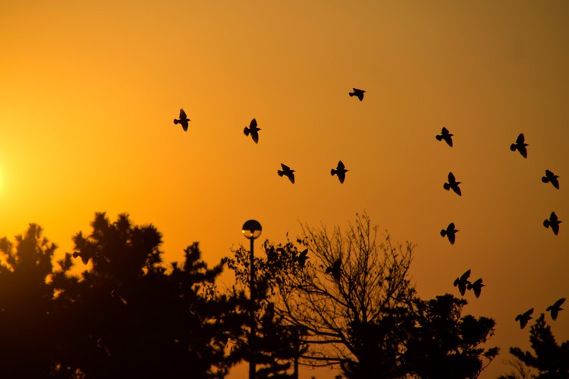
Table 1: Caption should be placed above the table.

 | A | B | C
(1) | 150% | 16.3% | 18.2%

Figure 1: Caption should be placed below the figure. Figure captions should be below the figures; table cap-
tions should be above the tables. They should be referred to in the text, for example, Fig. 1, or Figs. 1 to 3.

Equations
Equation numbers should be Arabic numerals enclosed in parentheses on the right-hand margin. They should be cited in the text as, for example, Eq. (1), or Eqs. (1) to (3). Equations start from the left of the column. Punctuate equations with commas or periods when they are part of a sentence. For example,

x˙ = Ax + Bu,
(1)

y = Cx + Du,

where x is the state vector.

References
References should appear in a separate bibliography at the end of the paper, with items referred to with numerals in square brackets [1]. Times Roman 10pt is used for refer- ences.

References
[1] I. S. Cie: The ISCIE Style File; ISCIE Journal, Vol. 0, No. 0, pp. 000–999 (2000)

